There is a **binary** tree rooted at 0 consisting of n nodes. The nodes are labeled from 0 to n - 1. You are given a **0-indexed** integer array parents representing the tree, where parents[i] is the parent of node i. Since node 0 is the root, parents[0] == -1.

Each node has a **score**. To find the score of a node, consider if the node and the edges connected to it were **removed**. The tree would become one or more **non-empty** subtrees. The **size** of a subtree is the number of the nodes in it. The **score** of the node is the **product of the sizes** of all those subtrees.

Return *the****number****of nodes that have the****highest score***.

**Example 1:**

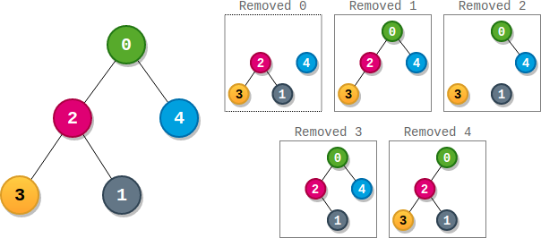

**Input:** parents = [-1,2,0,2,0]

**Output:** 3

**Explanation:**

- The score of node 0 is: 3 * 1 = 3

- The score of node 1 is: 4 = 4

- The score of node 2 is: 1 * 1 * 2 = 2

- The score of node 3 is: 4 = 4

- The score of node 4 is: 4 = 4

The highest score is 4, and three nodes (node 1, node 3, and node 4) have the highest score.

**Example 2:**

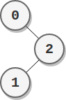

**Input:** parents = [-1,2,0]

**Output:** 2

**Explanation:**

- The score of node 0 is: 2 = 2

- The score of node 1 is: 2 = 2

- The score of node 2 is: 1 * 1 = 1

The highest score is 2, and two nodes (node 0 and node 1) have the highest score.

**Constraints:**

* n == parents.length
* 2 <= n <= 105
* parents[0] == -1
* 0 <= parents[i] <= n - 1 for i != 0
* parents represents a valid binary tree.